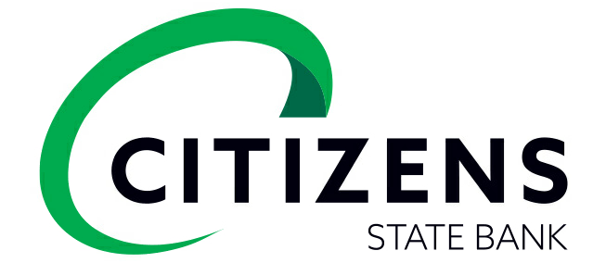

**COMMUNITY REINVESTMENT ACT NOTICE**

Under the Federal Community Reinvestment Act (CRA), the Federal Reserve Board (Board) evaluates our record of helping to meet the credit needs of this community consistent with safe and sound operations. The Board also takes this record into account when deciding on certain applications submitted by us.

Your involvement is encouraged.

You are entitled to certain information about our operations and our performance under the CRA, including, for example, information about our branches, such as their location and services provided at them; the public section of our most recent CRA Performance Evaluation, prepared by the Federal Reserve Bank of Kansas City; and comments received from the public relating to our performance in helping to meet community credit needs, as well as our responses to those comments. You may review this information today.

At least 30 days before the beginning of each calendar quarter, the Federal Reserve System publishes a list of the banks that are scheduled for CRA examination by the Reserve Bank in the next two quarters. This list is available from the Assistant Vice President of Consumer Affairs, Federal Reserve Bank of Kansas City, 1 Memorial Drive, Kansas City, MO 64198-0001, or through the Board's website at https://www.federalreserve.gov.

You may send written comments about our performance in helping to meet community credit needs to Assistant Vice President of Consumer Affairs, Federal Reserve Bank of Kansas City, 1 Memorial Drive, Kansas City, MO 64198-0001, or through the Board's website at https://www.federalreserve.gov. Your letter, together with any response by us, will be considered by the Federal Reserve System in evaluating our CRA performance and may be made public. You may ask to look at any comments received by the Reserve Bank.

You may also request from the Reserve Bank an announcement of our applications covered by the CRA filed with the Reserve Bank. We are an affiliate of Citizens National Corporation, a bank holding company. You may request from Assistant Vice President of Applications, Federal Reserve Bank of Kansas City, 1 Memorial Drive, Kansas City, MO 64198-0001 an announcement of applications covered by the CRA filed by bank holding companies.